Progress Reports

Kurt Robinson

# Progress Report for 19th March

## Week One

The project assigned requires us to develop a piece of software that serves as a dashboard capable of visualising data in a meaningful way and allowing the user to manipulate the given data. This progress report was written two days after our first meeting and its purpose is to provide an insight into how development of this project is coming along.

As we have only had one day since our first meeting we were still able to go over our project specification and identify who the stakeholders of the software would be, we also discussed some requirements that the software would have to fulfil as well as some resources that we would require in order to properly develop this software.

During our meeting we dedicated some time into opening the archive files given to us and conducting research to get an early idea of what type of data we would have to work with throughout this project.

## Decision Table

|  |  |  |
| --- | --- | --- |
| Description | Decision | Priority |
|  |  |  |
| Design Methodology | We have chosen to follow the agile development methodology.  It is preferable to each group member as we wish to complete tasks in bursts using an incremental and iterative method. | Neutral |
|  |  |  |
| Programming Language | Our choices were between Cocoa, C++, Java or Visual Basic.  Our final decision will be based on ease of use and its ability to support a GUI, for now it is undecided as it is not a high priority at this point in time. | Low |

## Issues

A large issue we had was not being able to have a group formed until the third week of semester, leaving us only four weeks to complete all our tasks until the first deliverable rather than 6. This means that we will need to organise frequent and extended group meetings in order to produce a quality report in time.

## Action Items

### Completed

*No action items had been set the previous week*

### Assigned

Action items that were assigned at the end of the meeting that we planned to have completed by the next week included a design plan, business case, an initial SRS, measuring effectiveness, milestones, risk analysis and a git repository created for the project.

## Current Status

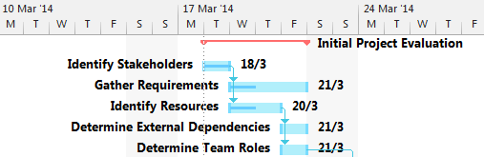

The Gantt chart does not show us much regarding how much has been completed since we have only had one day to put work into the task.

# Progress for 26th March

## Week Two

This week we had all members present during the Tuesday tutorial so we were able to set a weekly date that we can all get together and simultaneously work on this project. The date chosen that suited us best was on Wednesdays at 5:30pm.

We were able to meet with the client and we gathered some requirements including security details, database updating, and user details. These are taken into more detail within the SRS document.

Peter has chosen to handle development on the front end of the software. Meaning he will handle the website and data visualisation while the others focus on the technical back end tasks.

Our team roles are as follows:

* James: Project Manager/Software Architect
* Kurt: Tool Specialist/Software Engineer
* Josh: Database Administrator
* Peter: UI Engineer/System Analyst
* Jamie: Software Engineer/Analyst

## Decision Table

|  |  |  |
| --- | --- | --- |
| Description | Decision | Priority |
|  |  |  |
| RDBMS* | We have chosen to use MySQL as our RDBMS due to its capabilities of supporting concurrent updating across multiple clients since our software will need to support many users at once. | Neutral |
|  |  |  |
| Team Roles | We all discussed preferable parts of the project that we would like to be a part of and were able to determine team roles from this. From doing this we were able to assign tasks to people with the role that would best suit them. Those roles are shown in this report. | High |
|  |  |  |
| Programming Language | We revisited this decision as we have looked into developing the software to be based inside a browser. This gave us two options of languages being PHP, JavaScript and Ruby. JavaScript has a tool named D3js tool that can be used to show graphs and visualise data aesthetically. However most of us decided that Ruby would be the best language for us to develop in as it also has many tools available and it is a simple language for us to learn. | Neutral |

*RDBMS: Relational Database Management System

## Issues

We had a small issue with communication where two members of our group had left early before our meeting with the client. However we were successfully able to complete our meeting with only three of us and gather more essential requirements.

## Action Items

### Completed

Through further discussion regarding development of the project we were able to come up with a design plan. A risk management report was also completed during the week and the milestones were decided on through creation of the Gantt chart. A git repository was also created with each team member added as collaborators.

### Assigned

Jamie and Kurt were assigned the feasibility study, Peter and Kurt were assigned the SRS, James and Josh were assigned the detailed plan. Everybody was advised to look into the Ruby language in their own time to become more familiar with what we will be coding with.

## Current Status

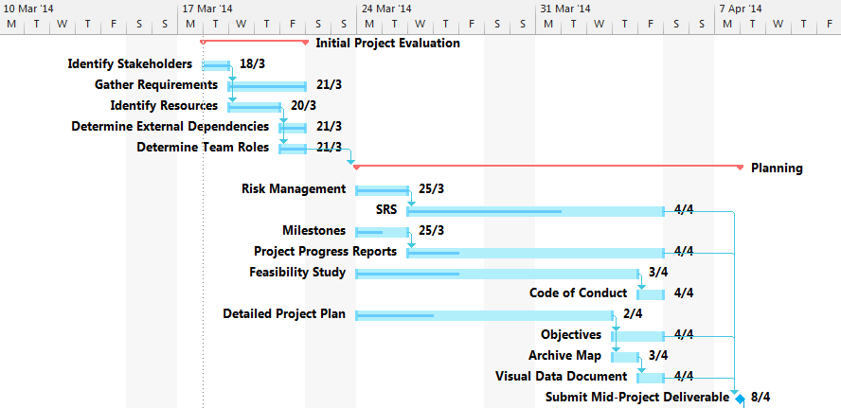

Once we were given team roles we were than able to work on our given tasks. We are now currently working on the SRS, Progress reports (this document), feasibility study and a project plan. The milestones document still requires completion.

# Progress for 16th April

## Week Three

After completing the mid deliverable and having a couple of days break, we decided to spend some time solely towards setting up our development environment. The reason for this was to ensure that each of us would have the same versions of programs and tools, thus preventing errors that may arise in the future due to incompatibility between software versions.

## Decision Table

|  |  |  |
| --- | --- | --- |
| Description | Decision | Priority |
|  |  |  |
| Database Editing Software | Sequel Pro. | Low |
|  |  |  |
|  |  |  |
|  |  |  |

## Issues

One issue we had with setting up the development environment was that Peter and Josh both use Windows PC’s for development whereas James, Jamie and Kurt use Apple Macs. This meant that we had to separate different tasks amongst different members to avoid incompatibility. We also had to go through who would have what software for each different operating system.

## Action Items

### Completed

123

### Assigned

123

## Current Status

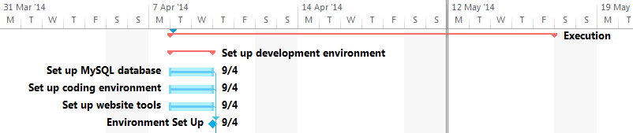

123

# Progress for 23rd April

## Week Three

abc

## Decision Table

|  |  |  |
| --- | --- | --- |
| Description | Decision | Priority |
|  |  |  |
| abc | 123 | High |
|  |  |  |
|  |  |  |

## Issues

123

## Action Items

### Completed

123

### Assigned

123

## Current Status

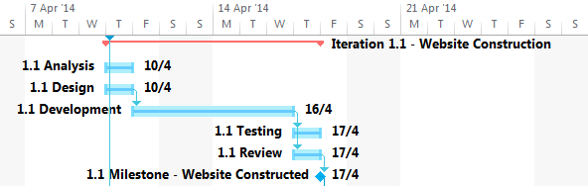

123

# Progress for 30th April

## Week Three

abc

## Decision Table

|  |  |  |
| --- | --- | --- |
| Description | Decision | Priority |
|  |  |  |
| abc | 123 | High |
|  |  |  |
|  |  |  |

## Issues

123

## Action Items

### Completed

123

### Assigned

123

## Current Status

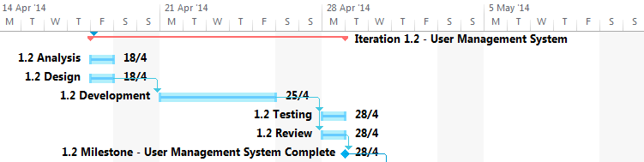

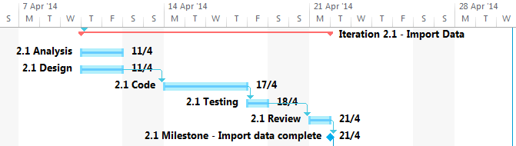

123

# Progress for 7th May

## Week Three

abc

## Decision Table

|  |  |  |
| --- | --- | --- |
| Description | Decision | Priority |
|  |  |  |
| abc | 123 | High |
|  |  |  |
|  |  |  |

## Issues

123

## Action Items

### Completed

123

### Assigned

123

## Current Status

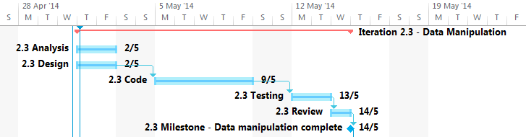

123

# Progress for 14th April

## Week Three

abc

## Decision Table

|  |  |  |
| --- | --- | --- |
| Description | Decision | Priority |
|  |  |  |
| abc | 123 | High |
|  |  |  |
|  |  |  |

## Issues

123

## Action Items

### Completed

123

### Assigned

123

## Current Status

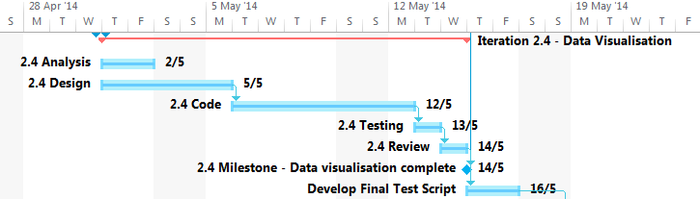

123

# Progress for 21st April

## Week Three

abc

## Decision Table

|  |  |  |
| --- | --- | --- |
| Description | Decision | Priority |
|  |  |  |
| abc | 123 | High |
|  |  |  |
|  |  |  |

## Issues

123

## Action Items

### Completed

123

### Assigned

123

## Current Status

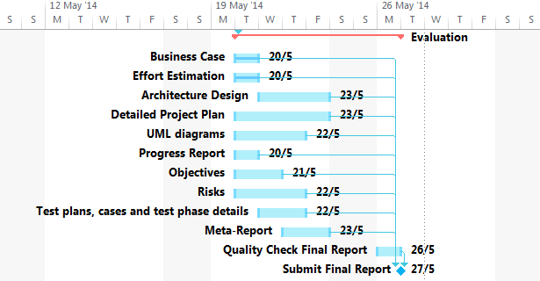

123

Meeting Records